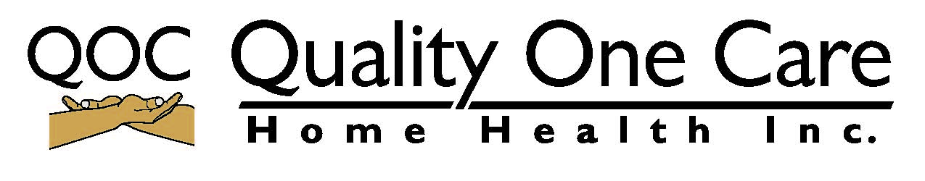
RN JOB DESCRIPTION
Report to; RN supervisor
Supervises: LPNs, CAN and HHA.
Qualifications:
- Education: Degree in nursing from an accredited Nursing school, current RN license.
- Experiences: 2 years clinical experience which include direct pediatric patient care within the last 2 years.
- Licensure: Current RN License
- Skills Knowledge of regulatory requirements and management processes.
- Interpersonal skills: Excellent oral and written communication skills.
- Must maintain current credentials, including CPR, 1st Aide, TB Test, Physical, Background check and complete all agency mandatory in-services.
General Function:
- Supervise LPN, CNA and HHA by visiting in the recipient’s home or at the recipient’s workplace, at a minimum of 30 days intervals, to evaluate the interactions and relationship between the recipients and personal care aides, to assess the aide’s performance and ability to give the required service.
- Instruct LPN,CNA and HHA concerning various services required under the plan of care for each recipient and about conditions which should be brought to the attention of Family Healthcare Services representative, case monitor or personal physician.
- Assists with providing patient care: records vital signs; discusses and records chief health concerns; performs tests; administers injections.
- Assists in the orientation and training of new employees and participates in their ongoing training. Act as resource person for nursing staff to answer questions, coach and supervise current staff in the performance of their job duties.
- Documents, investigates and responds to concerns, issues, and complaints at the first level quickly and appropriately. Reports all operational issues promptly to the Director of Nursing to avoid repeat of inefficiencies and to improve overall quality in the department.
- Responsible for assessing the performance of LPN, CNA and HHA.
- Administer treatments and medications in the care of the ill, injured, or infirm, the maintenance of health, and prevention of illness, under the direction of a registered nurse and physician.
- Report changes in the patient's condition to the registered nurse, and these reports shall be documented in the clinical notes.
- Prepare clinical notes for the clinical record.
- Places phone calls to pharmacies to order prescriptions; sets-up referral contacts.
- Pulls and prepares patient charts; answers phone; performs other general office duties as required.
- Maintains neatness of work area; stocks patient rooms with supplies.
- Performs other duties as assigned.

Name: ____________________________________________Signature: _________________________________ Date: _______________

