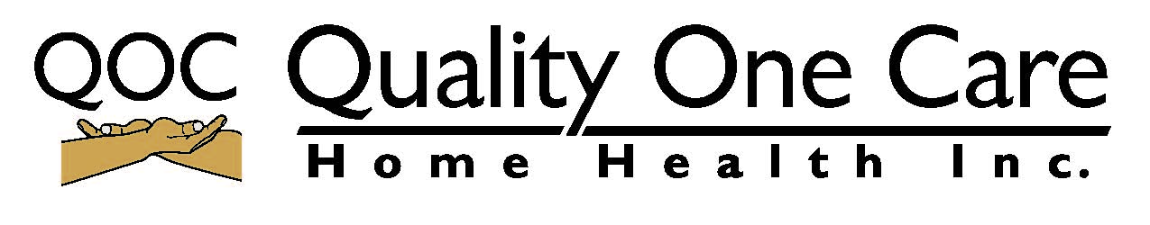

Dear RN, LPN & CNA
Thank you for interest in Quality one care Home Health Inc. In order to complete this application, please make sure to sign all forms and provide updated originals (copies to be made at the office) of the following documents:
- Malpractice insurance
- Driver’s license
- Proof of employment eligibility ( Green card, Passport, Work authorization, Certificate of citizenship)
- CPR (BLS)
- Social Security Card
- Recent background check for child care
- Current physical exam

E-Mail: info@qualityonecare.com
Fax: (301) 658-2328
Tel: (301) 658-7141
SCHEDULLING: 240-467-6435

Finger print information: CHILD CARE (365 Days)
- ORI : MD004455Y
- Authorization number :1200000653
- PDN Service no: 0500040015
- Name of Agency : Quality One Care Home Health Inc

NURSING MALPRACTICE INSURANCE
1.NSO
Phone number:1-800-247-1500
Web site: www.nso.com
2.ACORD
Phone number:1-800-221-4904
Email address: info@cmfgroup.com

